**MORNING STAR SCHOOL**

**ACADEMIC SESSION 2024-25**

**HOLIDAY HOMEWORK**

Summer Vacations Are Here!!

Dear children,

We are sure that you all will enjoy your holidays. You must have started making plans to visit your grandparents, relatives and friends, watching television, taking a dip in the swimming pool and joining some summer activities camps. We wish that you enjoy every minute of this long break with your family and friends. It will be great if you are able to find time to visit museum and monuments. Learn new things, explore new areas near your house, play indoor and outdoor games, read many story books, help your parents and grandparents, go for morning walk and play in the park in the in the Evening during your long summer break. We are giving you a variety of fun-filled activities and worksheets which you can do during this time. Do them neatly and submit the worksheets to your teachers after the vacation. Wish you all have very enjoyable and fun-packed summer break.

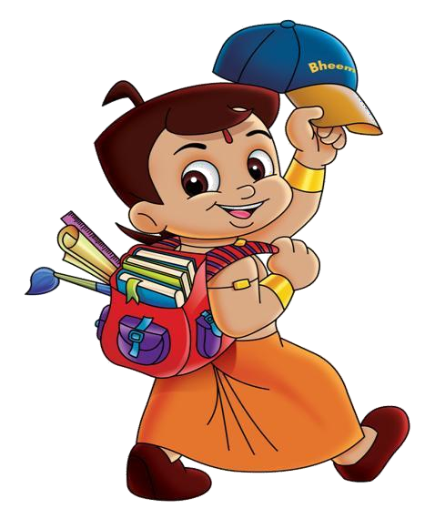Enjoy!!!

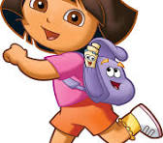

**Subject:-ENGLISH *Class-II***

* Practice one page cursive handwriting daily in a separate 4 line 60 page notebook.
* Revise and learn poem-Caterpillar (page number-14) Course Book.
* Do reading practice of Chapter-2 Under My Bed –Course Book.
* Paste pictures of any two wild animals and write five lines about each of them with their names.
* Complete the given English worksheets and attach with scrapbook.
* Write 6 action words and paste pictures related to them.
* Learn all the work done in notebook and textbooks.
* To improve your reading skills you can read good free online story books from the following links in this vacation.

https://monkeypen.com/pages/free-stories-for-ki

***WORKSHEET-1***

Name:---------------

**A) Colour the balloons with common noun-Red and color the balloons with proper noun - Blue .**

***Narendra Modi paper Ganga mountain***

*** ***

***Gita tree pencil jackfruit Cake***



***tubelight Shivaji ball temple***

**B). Find theses special names (Proper Nouns) in the grid below:**

**The special name of :**

**1. a day**

**2.a book**

**3. a city**

**4. a river**

**5. a month**

**6. a festival**

**7. a country**

**8. our country**

**9. the city in which we have the Taj Mahal**

|  |  |  |  |  |  |  |
| --- | --- | --- | --- | --- | --- | --- |
| **A** | **F** | **R** | **I** | **S** | **M** | **C** |
| **F** | **R** | **A** | **N** | **C** | **E** | **H** |
| **A** | **I** | **A** | **D** | **E** | **L** | **E** |
| **P** | **D** | **G** | **I** | **T** | **A** | **N** |
| **R** | **A** | **R** | **A** | **N** | **G** | **N** |
| **I** | **Y** | **A** | **M** | **U** | **N** | **A** |
| **L** | **D** | **I** | **W** | **A** | **L** | **I** |

***WORKSHEET-2***

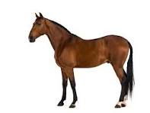***A) Arrange the words written with each picture (column B) in alphabetical order***

**1.**

**9.**

**2.**

**3.**

**8.**

**7.**

**6.**

**4.**

**5.**

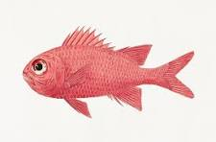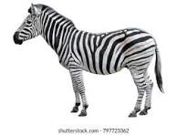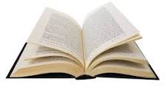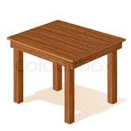

**Drop**

**Zebra**

**Sun**

**Table**

**Book**

**Horse**

**Fish**

**Gun**

**Egg**







**B)Write the given words in alphabetical order:**

**1. milk mango money month**

**____________________________________________________**

**2. Food finger fast flow funny**

**___________________________________________________**

**3.Game gun gift glass gentle**

**___________________________________________________**

**4.pen pup plum pin pond**

**___________________________________________________**

**5.owl onion olive oats ocean**

**___________________________________________________**

**Subject:-EVS *Class-II***

* Read chapter-1 and 2.
* Revise work done in class work notebook and textbook.
* Tell what are the sources of the following cloth materials-silk, jute, cotton, wool. Paste a picture of the source of each of these.
* Draw a picture of any one of your favorite fruit and a vegetable and write three lines about each of them.
* Complete the given EVS worksheets and attach with your scrapbook.

**WORKSHEET-1**

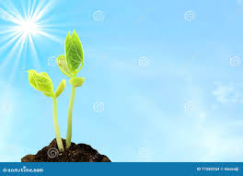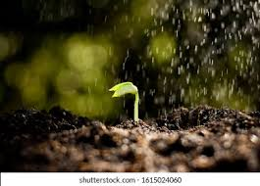**A) The following pictures tell us how a seed becomes a plant. Number the pictures in the correct order.**

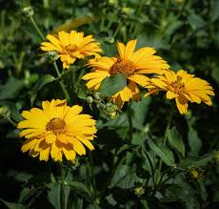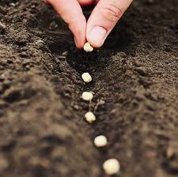

**Fill in the blanks with the words given below.**

**Rain flowers soil plant sun**

1. We put a seed in the __________________.

2. ________________ falls on the seed and it starts to grow a little.

3. The__________________ shines on it and it grows a bit more.

4. The seed now has become a __________________.

5. There are two bright yellow _________________too.

**Show-and-Tell**

**With the help of an elder, plant a few seeds in a small pot. Look after them well. The seeds will grow in a few days. Take the picture of plant how much it grow every week and send to your class teacher on whatsapp. Bring this pot to class and talk about it. Share how you looked after it.**

**WORKSHEET-2**

**A)Label the materials that have been used to make the house shown below.**

**glass wood**

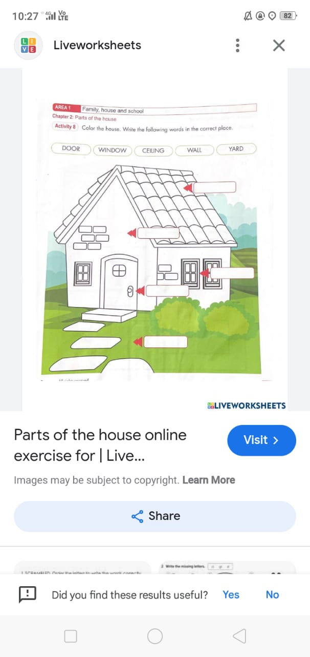 **bricks**

**cement stone**

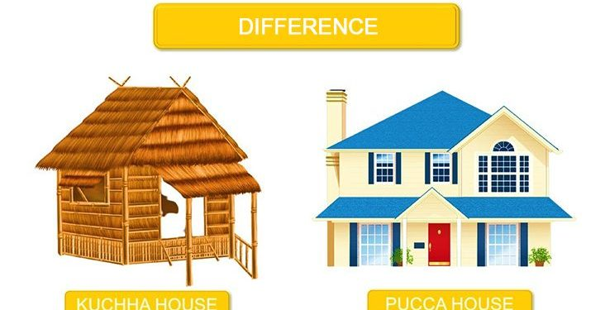**B)Encircle the words that related to the corresponding pictures.**

**Strong village mud cement bricks cement weak straw**

**straw bamboo not strong steel mud bamboo city**

**Subject:-MATHEMATICS *Class-II***

* Do practice of work done in class.
* Learn and write tables from 2 to10.
* Write back counting ( 100 To 1)

.

**WORKSHEET-1**

**Q1.) Fill in the missing numbers.**

**i) 2 ______ ________ 8 ______ ______ 14**

**ii) 40 ______ 44 ______ ______ 50 ______**

**iii) 5 ______ 15 ______ ______ 30 ______**

**iv) 40 ______ 60 ______ ______ 90 ______**

**Q2.) Colour the ice-Cream cones according to the instruction given below:-**

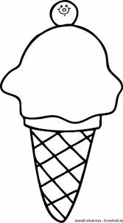

**a) Colour the first cone with yellow**

**b) Colour the second cone with red**

**c) Colour the fifth cone with blue**

**d) Colour the third cone with green**

**e) Colour the Sixth cone with pink**

**f) Colour the fifth cone with orange**

**Q3.) Arrange the following numbers in ascending order:-**

**a) 71, 65, 13, 11**

**b) 89, 33, 108, 100**

**Q4.) Arrange the following numbers in descending order:-**

**a) 90, 10, 30, 89**

**b) 78, 72, 2, 93**

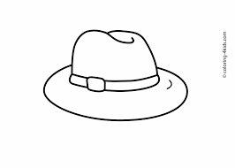**Q 5.) Colour 4th hat from the left**



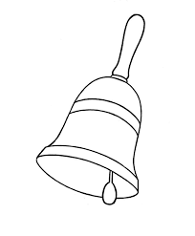**b) Colour 6th bell from the left**

Q.7 Do activity ( colour) odd number with blue and even number with red

**24**

**63**

**41**

**12**

**8**

**93**

**11**

**54**

**Q.3 Colour the largest number with green and smallest number with yellow.**

**63**

**22**

**10**

**99**

**16**

**Q.4 Addition–**

1) 5 + 9

2) 4. + 8

**Q.5 Circle the largest number.**

197 20 244 240

999 43 64 560

**Q.6 Circle the smallest number.**

300 84 92 70

500 10 6 90

**Subject:-HINDI *Class-II***

* कक्षा में कराए गए कार्य को दोहराएं।
* एक पेज सुलेख रोज लिखें ( पतली कॉपी मै )
* अपने अच्छे मित्र के बारे मै (ik¡p वाक्य लिखें )
* पेड़ों के महत्व के ऊपर ik¡p वाक्य लिखो।
* पेड़ों के चित्र चिपकाएं और उनके नाम लिखें।
* सवेरे सवेरे ( कविता ) याद करें और लिखें।
* मांसाहारी तथा शाकाहारी जानवरों के नाम लिखें।
* 'अ' और 'आ'की ध्वनी वाले तीन-तीन शब्द लिखें।

**WORKSHEET-1**

**प्रश्न.1 सोचो और लिखो। (ik¡p वाक्य )**

यदि सूरज नहीं होता तो क्या होता ?

1 ) _________________________________________

2 ) _________________________________________

3 ) _________________________________________

4 ) _________________________________________

5 ) _________________________________________

**प्रश्न 2 शब्द बनाओ (ई ) की मात्रा लगाकर**

1 ) दोस्त। + ई

2 ) हाथ + ई

3 ) पान + ई

4 ) साथ + ई

**प्रश्न 3 गोला लगाओ**

**वर्ग मै से अलग शब्द पर गोला लगाओ।**

1 कछुआ। मछली। शेर

2 मेज़। कुर्सी। बिल्ली

3 कमल। बंदर। गुलाब

4 खरगोश। बर्फी। जलेबी

**प्रश्न 4 वाक्य बनाओ।**

1 गर्मी- _____________________________________

2 सूरज- _____________________________________

3 ताजमहल- _____________________________________

**प्रश्न 5 मिलन करो।**

बादल टर्र टर्र

चिड़िया हरे

मेंढक पानी

पौधे नाच

मोर ची ची

**प्रश्न 6 नाचना शब्द नाच से बना है इसी तरह और शब्द बनाओ। (ना) जोड़कर**

1 ) बैठ- ______________

2 ) तैर- ______________

3 ) उठ- ______________

4 ) डर- ______________

**प्रश्न 7 गाय के ऊपर पांच लाइन लिखो।**

1) __________________________________________________

2) __________________________________________________

3) __________________________________________________

4) __________________________________________________

5) __________________________________________________

**Subject:-COMPUTER *Class-II***

1. **Draw a computer system in chart paper.**
2. **Learn advantage and disadvantage of computer.**

**Subject:-ART & CRAFT *Class-II***

**Make your home with different geometrical shapes (Home Scenery)**

**Material- Colourful geometrical shapes cut out, Chart paper, Colours, Scissors Glue, decorative material**

**NOTE:- All the work should be done in scrap book.**

**\*ACTIVITY RECOMMENDED DURING VACATION\***

* Meditate and do simple yoga exercises .
* Water plants and feed the birds.
* Join your grandparents and parents for their morning walk.
* Help your mother in the kitchen .
* Don’t watch too much of television .
* keep your environment in surrounding clean .
* Plant trees and conserve your natural resources.
* Build and improve your vocabulary through crosswords, jumble words etc.
* Solve riddles and puzzles.
* Read story books and visit places.
* Improve your reading and writing skills by reading and writing.

**Note:**

* **Summer breaks are from 5th May to 23 June 2024. The school will**

**reopens on 24th June 2024**

***Have a great***

***Summer Vacation***